**Setting Up Prometheus Monitoring and Slack Alerts in Kubernetes**

**Introduction**

Monitoring and alerting are essential for maintaining the health, performance, and security of Kubernetes clusters. By integrating **Prometheus** for monitoring, **AlertManager** for alerting, and **Slack** for notifications, you can proactively address critical issues, such as vulnerabilities detected by **Trivy**. This guide simplifies and deepens the process of configuring these tools, ensuring clarity at every step.

**Objective**

**Goals**

1. Install and configure the **kube-prometheus-stack** Helm chart for Prometheus and AlertManager.
2. Set up **PrometheusRule CRDs** to define conditions for alerts.
3. Configure **AlertManager** to route alerts to a Slack channel.
4. Test and verify the setup end-to-end, resolving common issues encountered in real-world scenarios.

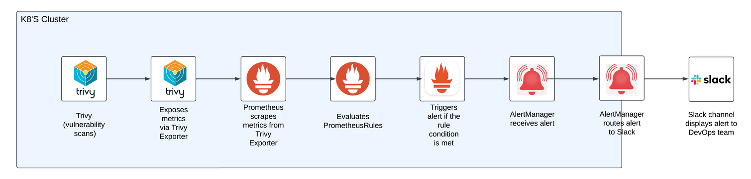

**Step-by-Step Setup**

**1. Install kube-prometheus-stack Helm Chart**

Prerequisites

* **Kubernetes cluster** with sufficient resources.
* Helm installed on your local machine.
* kubectl is configured to access your cluster.

**Installation**

Add the Prometheus community Helm repository and install the stack:

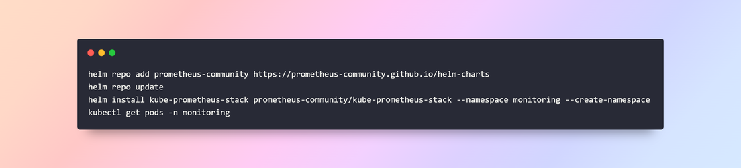

Key components include:

* **Prometheus**: Collects and stores metrics.
* **AlertManager**: Sends alerts to destinations like Slack.
* **Grafana**: Provides dashboards for visualization.

**2. Configure Prometheus and AlertManager**

**Modify**, observability-conf\prom-values-alertmanager.yaml

* To make Prometheus discover custom rules and configure Slack notifications, update the values.yaml file. This step is critical and often overlooked in existing documentation

clone Github repo and update, observability-conf\prom-values-alertmanager.yaml

<https://github.com/sarvadnyaJawale/monitor-security-olly-in-Kubernetes-.git>

Prometheus **RuleSelector** and **ServiceMonitorSelector**

* This ensures Prometheus picks up the custom alert rules and monitors:

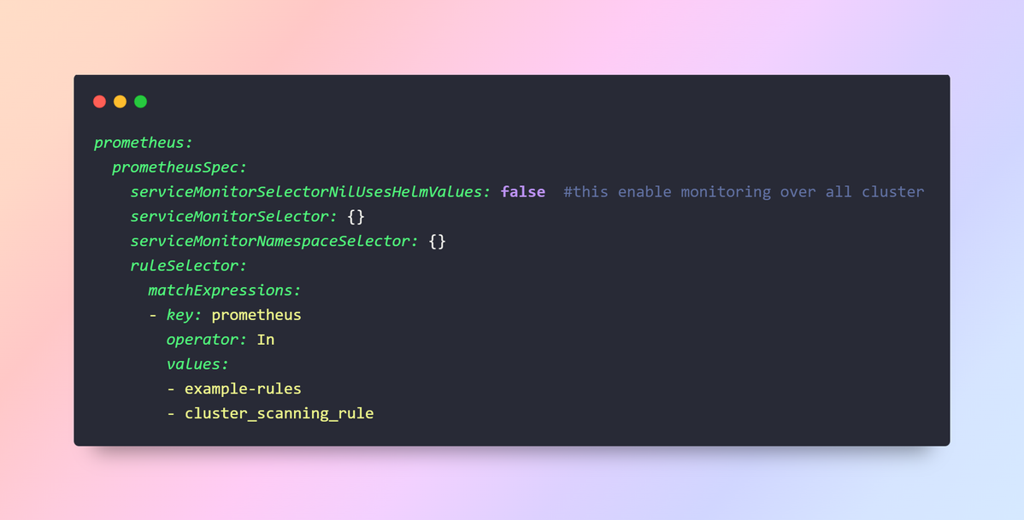

* **ruleSelector**: Filters PrometheusRules by label. Here, only rules labeled prometheus: cluster_scanning_rule are considered.
* **serviceMonitorSelectorNilUsesHelmValues: false**: Ensures only explicitly defined ServiceMonitors are used, avoiding unwanted defaults.

**AlertManager Configuration for Slack**

Configure Slack as the alert receiver:

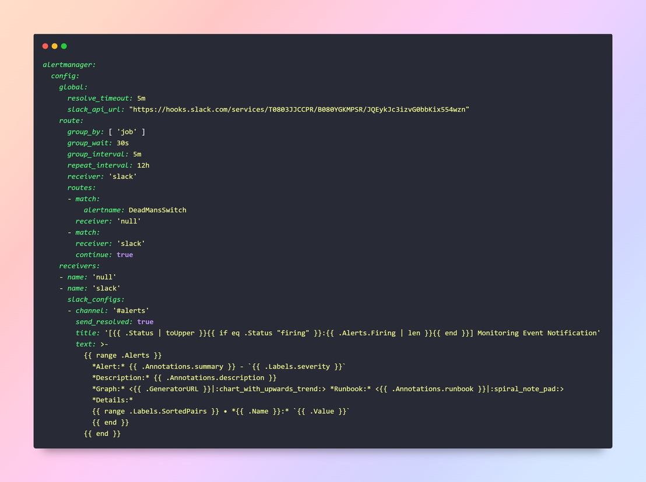

* **resolve_timeout**: Time after which unresolved alerts are dropped.
* **slack_api_url**: Webhook URL for Slack integration.
* **route**: Defines how alerts are grouped and forwarded.
* **receivers**: Configures Slack as the destination for alerts.

**Apply Updated Configuration**

* Upgrade the Helm chart with the modified prom-values-alertmanager.yaml



This step applies your configurations to Prometheus and AlertManager. Though seemingly simple, this step is often omitted in documentation.

**Create PrometheusRule CRDs**

* PrometheusRules define alert conditions.

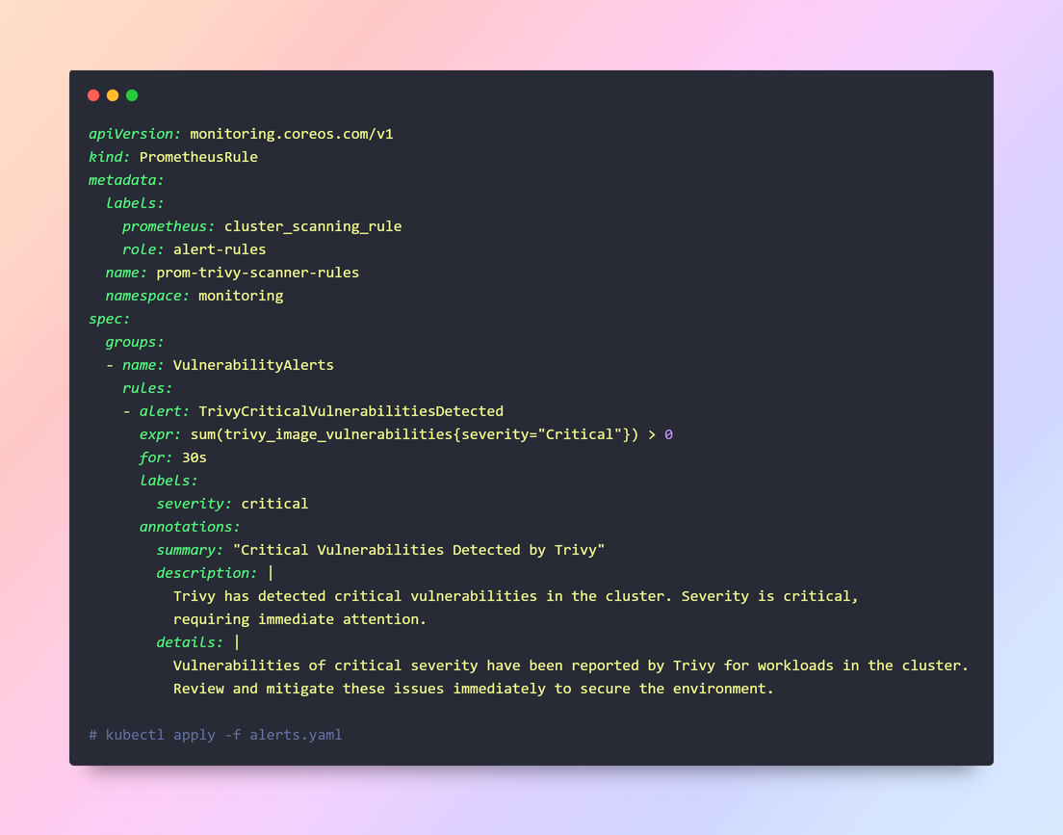

**Verify Setup**

* Expose Prometheus UI
* Port-forward Prometheus to access its web UI:

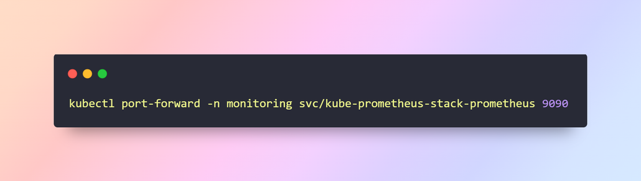

**Verify:**

1. **Metrics**: Check if Trivy metrics are scraped under **Targets → trivy-exporter**.
2. **Rules**: Ensure trivy-alerts.yaml rules are loaded under **Status → Rules**.

**Simulate an Alert**

Induce a test condition (e.g., deploy a vulnerable container). Check:

* Alerts are displayed under **Alerts** in Prometheus.
* Notifications are sent to the Slack channel.

**Workflow: Trivy to Slack Alerts**

**Trivy Scans and Metrics Export**:

* **Process**:
  + Trivy runs as a **Kubernetes DaemonSet or CronJob** to scan container images in the cluster for vulnerabilities.
  + The results are converted into **Prometheus-compatible metrics** and exposed via the **Trivy Exporter** at an HTTP endpoint (/metrics).
* **Technical Note**:
  + Trivy's metrics include fields like trivy_image_vulnerabilities{severity="Critical"}.
  + The **Trivy Exporter Service** in the trivy-system namespace provides these metrics.

**Prometheus Scrapes Metrics**:

* **Process**:
  + Prometheus, deployed via the kube-prometheus-stack, scrapes the Trivy metrics from the **Trivy Exporter Service**.
  + Metrics scraping is configured via a **ServiceMonitor CRD**, which specifies the namespace, service, and endpoints.
* **Key Configuration**:
  + serviceMonitorSelector in Prometheus's values.yaml ensures the discovery of the Trivy ServiceMonitor.

**Rule Evaluation in Prometheus**:

* **Process**:
  + Prometheus evaluates custom **PrometheusRules** (e.g., trivy-alerts.yaml) defined for Trivy metrics.

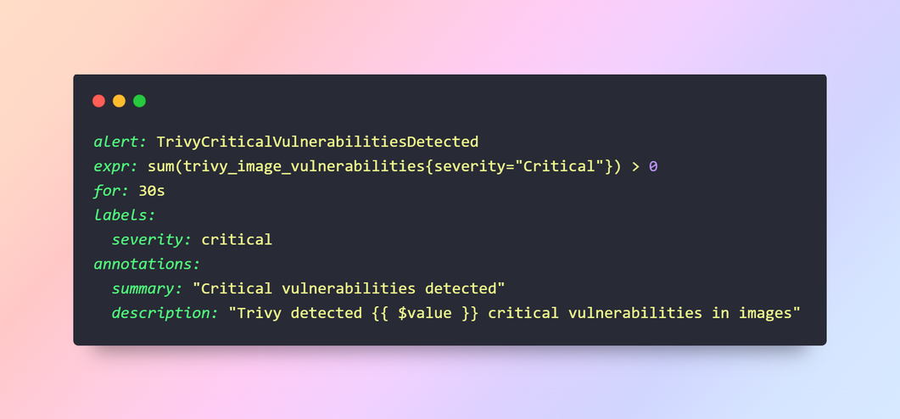

* If the condition (expression) evaluates to true, an alert is triggered.

**Alert Forwarding to AlertManager**:

* **Process**:
  + Prometheus forwards triggered alerts to **AlertManager**, which is configured to handle alert routing.
* **Configuration**:   
  alertmanager.config specifies alert grouping and forwarding rules:

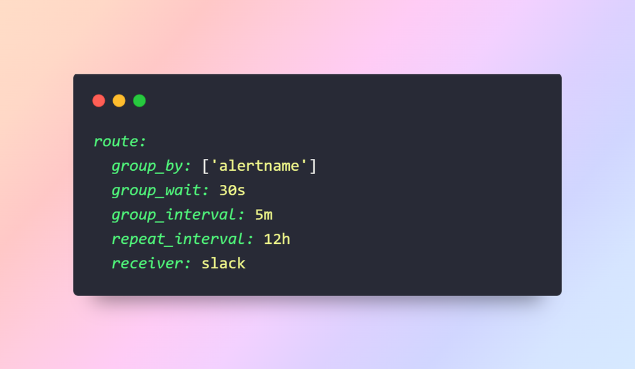

* Alerts are routed to the slack receiver.

**AlertManager Sends Notifications to Slack**:

* **Process**:
  + AlertManager uses the configured **Slack API webhook** to send alert notifications to the specified Slack channel.
* **Key Slack Configuration**:
  + slack_configsin AlertManager's receiver definition:
  + yaml
  + Copy code

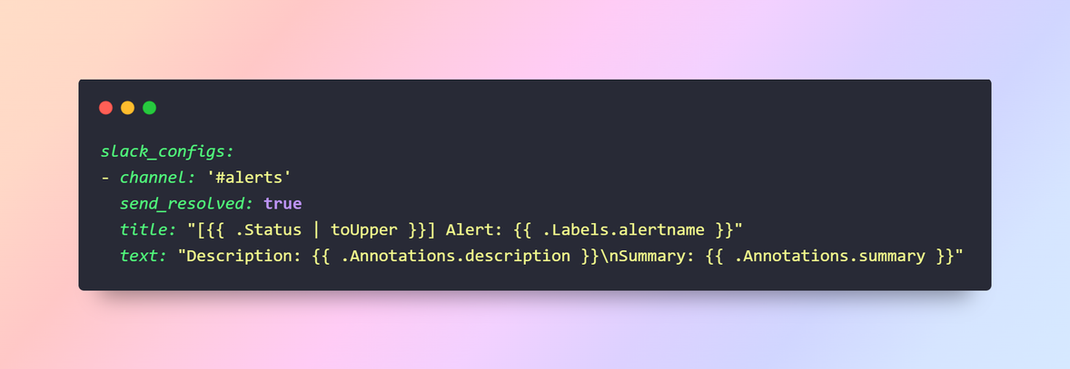

**Notification Reaches Slack Channel**:

* **Outcome**:
  + The Slack channel (e.g., #alerts) receives a detailed alert message, enabling DevOps teams to act quickly.

**Sample Slack Message**:

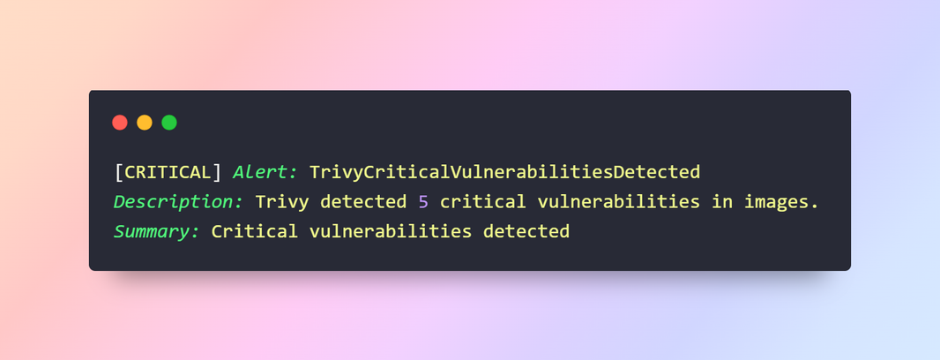

**Technical Flow Summary**

1. **Trivy (Vulnerability Scanner)**:
   * Runs scans → Generates metrics → Exposes metrics via /metrics.
2. **Prometheus**:
   * Scrapes metrics from Trivy → Evaluates rules → Triggers alerts for critical conditions.
3. **AlertManager**:
   * Receives alerts from Prometheus → Routes alerts to Slack based on routing rules.
4. **Slack**:
   * Displays notifications to the configured channel for operational visibility.



**Common Challenges and Resolutions**

**1. Prometheus Rules Not Triggering Alerts**

* **Cause**: Namespace mismatch or missing ruleSelector.
* **Solution**: Match PrometheusRule namespace (monitoring) and ensure proper ruleSelector.

**2. Metrics Not Visible**

* **Cause**: Trivy metrics not scraped.
* **Solution**: Ensure Trivy metrics are exposed and serviceMonitorSelector targets the namespace.

**3. Slack Notifications Failing**

* **Cause**: Invalid slack_api_url or routing issues.
* **Solution**: Verify Slack webhook URL and ensure AlertManager routes point to the Slack receiver.

**Component Breakdown**

1. **Prometheus**: Scrapes metrics and evaluates rules.
2. **AlertManager**: Routes alerts based on rules to configured receivers (e.g., Slack).
3. **Trivy**: A vulnerability scanner that generates metrics for container images.
4. **Slack Integration**: Ensures rapid visibility for critical alerts.

**Best Practices**

1. **Namespace Consistency**: Align namespaces across Prometheus, AlertManager, and Trivy.
2. **Rule Testing**: Validate all alert rules in a staging environment before production.
3. **Documentation**: Maintain clear documentation for rule configurations and alert workflows.
4. **Helm Upgrade**: Always use helm upgrade after modifying values.yaml

**Takeaways and Further Resources**

**Lessons Learned**

* Proper values.yaml configurations are critical for Prometheus and AlertManager.
* Namespace mismatches are a common source of issues; always verify configurations.
* Testing alert workflows ensures reliability.

**Resources**

* Prometheus Documentation
* AlertManager Configuration
* Trivy Documentation

**This documentation provides a detailed yet easy-to-follow approach, ensuring even those new to Prometheus can succeed with the setup.**

**Conclusion**

In this documentation, we walked through the comprehensive setup of **monitoring and alerting in Kubernetes** using Prometheus, AlertManager, and Slack, focusing on Trivy for vulnerability scanning. This workflow ensures real-time visibility into critical vulnerabilities and facilitates rapid incident response through seamless Slack notifications. By following these detailed steps, you can enhance the security and operational efficiency of your Kubernetes cluster, making it more robust and reliable.

**A Note from My Experience**

While Prometheus and its ecosystem are powerful tools for monitoring and alerting, my experience configuring this workflow exposed some significant pain points:

1. **Documentation Gaps**:
   * I found the **official Prometheus documentation** lacked clarity on certain configurations, especially for integrating custom rules like PrometheusRule and setting up serviceMonitorSelector. Important details—like the need to add these configurations to values.yaml and upgrade the Helm chart—were scattered or missing entirely.
2. **Configuration Pitfalls**:
   * Small oversights, such as namespace mismatches and omitted ruleSelector configurations, caused critical alerts to fail silently. These issues consumed unnecessary hours of troubleshooting and testing.
   * The lack of consolidated, practical examples for Slack integration further compounded the challenges.

**Conclusion**

In this documentation, we walked through the comprehensive setup of **monitoring and alerting in Kubernetes** using Prometheus, AlertManager, and Slack, focusing on Trivy for vulnerability scanning. This workflow ensures real-time visibility into critical vulnerabilities and facilitates rapid incident response through seamless Slack notifications. By following these detailed steps, you can enhance the security and operational efficiency of your Kubernetes cluster, making it more robust and reliable.

**A Note from My Experience**

While Prometheus and its ecosystem are powerful tools for monitoring and alerting, my experience configuring this workflow exposed some significant pain points:

1. **Documentation Gaps**:
   * I found the **official Prometheus documentation** lacked clarity on certain configurations, especially for integrating custom rules like PrometheusRule and setting up serviceMonitorSelector. Important details—like the need to add these configurations to values.yaml and upgrade the Helm chart—were scattered or missing entirely.
2. **Configuration Pitfalls**:
   * Small oversights, such as namespace mismatches and omitted ruleSelector configurations, caused critical alerts to fail silently. These issues consumed unnecessary hours of troubleshooting and testing.
   * The lack of consolidated, practical examples for Slack integration further compounded the challenges.

**If You Need Help**

If you find yourself stuck or facing similar difficulties while implementing Prometheus or Kubernetes monitoring workflows, don’t hesitate to reach out!  
You can connect with me here:

* **LinkedIn**: [Sarvadnya Jawle](https://www.linkedin.com/in/sarvadnya-jawle)
* **Email**: sarvadnyajawle@gmail.com

I understand how frustrating these setups can be, and I’d be happy to assist or share insights from my journey.

**Thank you for taking the time to read through this guide, and I hope it saves you the hours of trial and error that I endured. Happy monitoring!**